Extra Accelerated Reader books
If you are struggling for books to read at home then the company who run Accelerated Reader are allowing free use of myOn, an online book program.
To access this, please type in the web address https://readon.myon.co.uk/ You should see a screen like this.
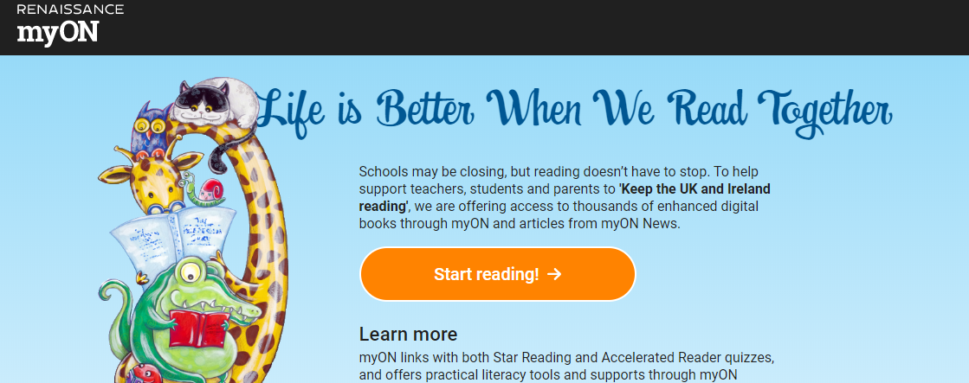
Click on start reading and it will take you to the library. If you click on search you can filter categories. I would start with year level.
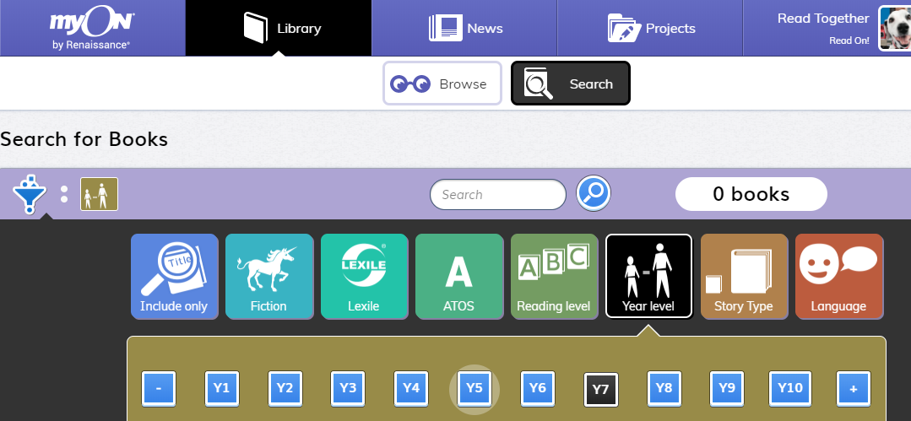
Once you have filtered which books you want to look at. You need to click the blue magnifying glass for the books to be filtered by your search.
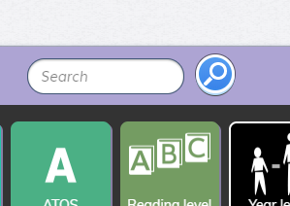

Once you have chosen a book to read, hover over it and click on info
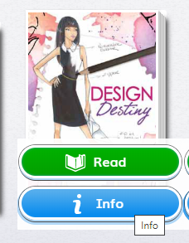
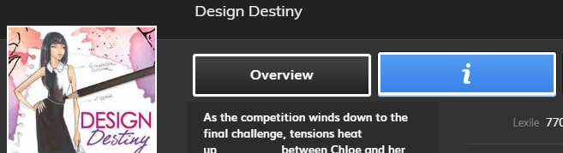
This will give you information about the book. If you then click on to the ‘I’ at the top of the information it will be able to tell you if it has an AR quiz attached to it.
It will give you the AR quiz number and how many points the book is worth.
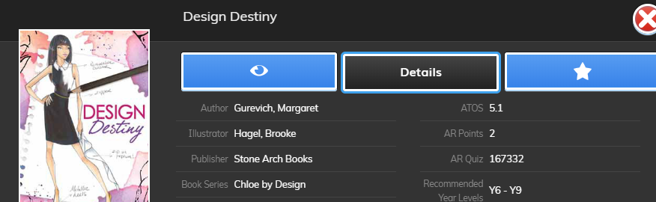
If you are happy to read that book, just click on the green book at the bottom and you can start reading.
You will need to log in to your normal Accelerated Reader account to quiz on the book. You cannot do it on this site, this is purely so you can access books and read them. Some of the books on there do not have Accelerated Reader quizzes attached to them, so it is best to look at the info before starting reading, if you want a book with a quiz attached to it. You can also click on news at the top if you want to have a look at news articles.
Any problems please contact me on teams or on email at kcussons@skegnessacademy.org and I will be able to help with any problems.

